**Stock price prediction**

Dynamics of Financial Markets

# Introduction:

Financial markets are the heart and soul of the global economy, facilitating the exchange of capital and resources, and serving as a barometer of economic health. Within the realm of financial markets, stock markets hold a central position, offering opportunities for investment and wealth creation. However, they are also characterized by their inherent volatility and unpredictability. The quest to understand and predict stock price movements has been a perpetual challenge for investors, traders, financial institutions, and researchers alike. Stock price prediction, as an interdisciplinary field, merges finance, statistics, data science, and economics to explore and forecast the complex dynamics of the stock market.

This comprehensive introduction to stock price prediction delves into the multifaceted aspects of this domain, providing insights into the methodologies, challenges, and applications that have emerged over the years.

# The Significance of Stock Price Prediction

**The Importance of Accurate Stock Price Prediction**

* Stock prices are a reflection of the collective wisdom and sentiment of market participants. Accurate predictions are essential for informed decision-making, risk management, and portfolio option.

**Key stakeholders**

* Investors, traders, financial institutions, and policymakers all rely on stock price predictions to varying degrees, impacting not only individual financial well-being but also the broader economic landscape.

**Historical Significance**

* The history of stock price prediction, from the early days of technical analysis to modern machine learning algorithms, highlights the evolution of tools and techniques in this field.

# Fundamental Analysis

**Understanding Fundamental Analysis**

* Fundamental analysis involves evaluating a company's financial health, industry conditions, and macroeconomic factors to estimate the intrinsic value of a stock.

**Key Metrics and Ratios**

* An exploration of metrics and ratios used in fundamental analysis, such as Price-to-Earnings (P/E), Price-to-Book (P/B), and Dividend Yield.

**Limitations and Challenges**

* The limitations of fundamental analysis, including the subjectivity of intrinsic value estimation and the impact of qualitative factors.

# Technical Analysis

**The Essence of Technical Analysis**

* Technical analysis is based on the premise that historical price and volume data contain patterns and trends that can inform future price movements.

**Common Technical Indicators**

* An overview of widely used technical indicators, including moving averages, Relative Strength Index (RSI), and Bollinger Bands.

**Chart Patterns**

* Recognizing and interpreting chart patterns like head and shoulders, double tops, and triangles to make predictions about price movements.

# Quantitative and Machine Learning Approaches

**Leveraging quantative methods**

Quantitative approaches involve mathematical models and statistical analysis to forecast stock prices. This section explores regression analysis and time series modeling.

**The Rise of Machine Learning**

* The application of machine learning techniques, including decision trees, support vector machines, and random forests, in stock price prediction.

**Deep Learning and Neural Networks**

* An in-depth look at how neural networks, including recurrent neural networks (RNNs) and convolutional neural networks (CNNs), have revolutionized stock price prediction.

# Sentiment Analysis

# **Harnessing Sentiment Data**

* The use of news articles, social media, and other sources to gauge public sentiment and its potential impact on stock prices.

**Text Mining and Natural Language Processing**

* Techniques for processing and analyzing textual data to quantify market sentiment.

# Market Psychology and Behavioral Analysis

**Behavioral Finance**

* An exploration of behavioral finance theories that explain how investor sentiment, cognitive biases, and market psychology influence stock price movements.

**The Role of Emotions**

* Delving into how emotions, such as fear and greed, can drive market behavior and the challenges they present for prediction models.

# External Factors

**Economic Indicators**

* The influence of economic indicators, such as GDP, inflation, and employment data, on stock prices and their predictive power.

**Geopolitical Events and Government Policies**

* The unpredictable impact of geopolitical events, trade agreements, and government policies on stock markets.

# Challenges and Limitations

# **Inherent Market Uncertainty**

* A discussion of the fundamental uncertainty associated with stock markets and its implications for prediction accuracy.

**Data Quality and Availability**

* The importance of data quality and the challenges associated with obtaining accurate and timely data for stock price prediction.

**Model Overfitting and Bias**

* The risk of overfitting and bias in prediction models and strategies to mitigate these issues.

# Ethical and Regulatory Considerations

**Ethical Dilemmas**

* The ethical implications of algorithmic trading, insider trading, and the responsibility of financial institutions in stock price prediction.

**Regulatory Framework**

* An overview of regulatory measures and organizations overseeing stock markets and trading practices.

# Applications of Stock Price Prediction

# **Investment Strategies**

* How stock price prediction is employed in different investment strategies, including value investing, growth investing, and momentum trading.

**Algorithmic Trading**

* The role of stock price prediction in algorithmic trading and high-frequency trading, emphasizing speed and accuracy.

**Risk Management**

* How stock price prediction supports risk assessment, portfolio diversification, and hedging strategies.

# Future Directions and Emerging Trends

**Learning Advancements Machine**

* The future of stock price prediction with advancements in machine learning, deep learning, and AI.

**Big Data and Alternative Data Sources**

* The potential impact of big data and alternative data sources, such as satellite imagery and social media data, on prediction models.

**Interdisciplinary Collaboration**

* The value of interdisciplinary collaboration among finance experts, data scientists, and behavioral psychologists in advancing stock price prediction.

Top of Form

**Exploratory Analysis**

To begin this exploratory analysis, first import libraries and define functions for plotting the data using matplotlib. Depending on the data, not all plots will be made.

Program and output

In [1]:

from mpl_toolkits.mplot3d import Axes3D

from sklearn.preprocessing import StandardScaler

import matplotlib.pyplot as plt *# plotting*

import numpy as np *# linear algebra*

import os *# accessing directory structure*

import pandas as pd *# data processing, CSV file I/O*

There is 1 csv file in the current version of the dataset:

In [2]:

for dirname, _, filenames **in** os.walk(' input'):

for filename **in** filenames:

print(os.path.join(dirname, filename))

input/MSFT.csv

.

unfold_less

In [3]:

*# Distribution graphs (histogram/bar graph) of column data*

def plotPerColumnDistribution(df, nGraphShown, nGraphPerRow):

nunique = df.nunique()

df = df[[col for col **in** df if nunique[col] > 1 **and** nunique[col] < 50]] *# For displaying purposes, pick columns that have between 1 and 50 unique values*

nRow, nCol = df.shape

columnNames = list(df)

nGraphRow = (nCol + nGraphPerRow - 1) / nGraphPerRow

plt.figure(num = None, figsize = (6 * nGraphPerRow, 8 * nGraphRow), dpi = 80, facecolor = 'w', edgecolor = 'k')

for i **in** range(min(nCol, nGraphShown)):

plt.subplot(nGraphRow, nGraphPerRow, i + 1)

columnDf = df.iloc[:, i]

if (**not** np.issubdtype(type(columnDf.iloc[0]), np.number)):

valueCounts = columnDf.value_counts()

valueCounts.plot.bar()

else:

columnDf.hist()

plt.ylabel('counts')

plt.xticks(rotation = 90)

plt.title(f'**{columnNames[i]}** (column **{i}**)')

plt.tight_layout(pad = 1.0, w_pad = 1.0, h_pad = 1.0)

plt.show()

unfold_less

In [4]:

*# Correlation matrix*

def plotCorrelationMatrix(df, graphWidth):

filename = df.dataframeName

df = df.dropna('columns') *# drop columns with NaN*

df = df[[col for col **in** df if df[col].nunique() > 1]] *# keep columns where there are more than 1 unique values*

if df.shape[1] < 2:

print(f'No correlation plots shown: The number of non-NaN or constant columns (**{df.shape[1]}**) is less than 2')

return

corr = df.corr()

plt.figure(num=None, figsize=(graphWidth, graphWidth), dpi=80, facecolor='w', edgecolor='k')

corrMat = plt.matshow(corr, fignum = 1)

plt.xticks(range(len(corr.columns)), corr.columns, rotation=90)

plt.yticks(range(len(corr.columns)), corr.columns)

plt.gca().xaxis.tick_bottom()

plt.colorbar(corrMat)

plt.title(f'Correlation Matrix for **{filename}**', fontsize=15)

plt.show()

unfold_less

In [5]:

*# Scatter and density plots*

def plotScatterMatrix(df, plotSize, textSize):

df = df.select_dtypes(include =[np.number]) *# keep only numerical columns*

*# Remove rows and columns that would lead to df being singular*

df = df.dropna('columns')

df = df[[col for col **in** df if df[col].nunique() > 1]] *# keep columns where there are more than 1 unique values*

columnNames = list(df)

if len(columnNames) > 10: *# reduce the number of columns for matrix inversion of kernel density plots*

columnNames = columnNames[:10]

df = df[columnNames]

ax = pd.plotting.scatter_matrix(df, alpha=0.75, figsize=[plotSize, plotSize], diagonal='kde')

corrs = df.corr().values

for i, j **in** zip(*plt.np.triu_indices_from(ax, k = 1)):

ax[i, j].annotate('Corr. coef = **%.3f**' % corrs[i, j], (0.8, 0.2), xycoords='axes fraction', ha='center', va='center', size=textSize)

plt.suptitle('Scatter and Density Plot')

plt.show()

Now you're ready to read in the data and use the plotting functions to visualize the data.

Let's check 1st file: /input/MSFT.csv

In [6]:

nRowsRead = 1000 *# specify 'None' if want to read whole file*

*# MSFT.csv may have more rows in reality, but we are only loading/previewing the first 1000 rows*

df1 = pd.read_csv('/kaggle/input/MSFT.csv', delimiter=',', nrows = nRowsRead)

df1.dataframeName = 'MSFT.csv'

nRow, nCol = df1.shape

print(f'There are **{nRow}** rows and **{nCol}** columns')

There are 1000 rows and 7 columns

Let's take a quick look at what the data looks like:

In [7]:

df1.head(5)

Out[7]:

|  | Date | Open | High | Low | Close | Adj Close | Volume |
| --- | --- | --- | --- | --- | --- | --- | --- |
| 0 | 1986-03-13 | 0.088542 | 0.101563 | 0.088542 | 0.097222 | 0.062549 | 1031788800 |
| 1 | 1986-03-14 | 0.097222 | 0.102431 | 0.097222 | 0.100694 | 0.064783 | 308160000 |
| 2 | 1986-03-17 | 0.100694 | 0.103299 | 0.100694 | 0.102431 | 0.065899 | 133171200 |
| 3 | 1986-03-18 | 0.102431 | 0.103299 | 0.098958 | 0.099826 | 0.064224 | 67766400 |
| 4 | 1986-03-19 | 0.099826 | 0.100694 | 0.097222 | 0.098090 | 0.063107 | 47894400 |

Distribution graphs (histogram/bar graph) of sampled columns:

In [8]:

plotPerColumnDistribution(df1, 10, 5)

<Figure size 2400x512 with 0 Axes>

Correlation matrix:

In [9]:

plotCorrelationMatrix(df1, 8)

Scatter and density plots:

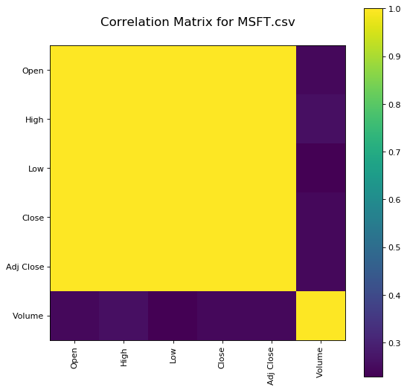

In [10]:

plotScatterMatrix(df1, 18, 10)

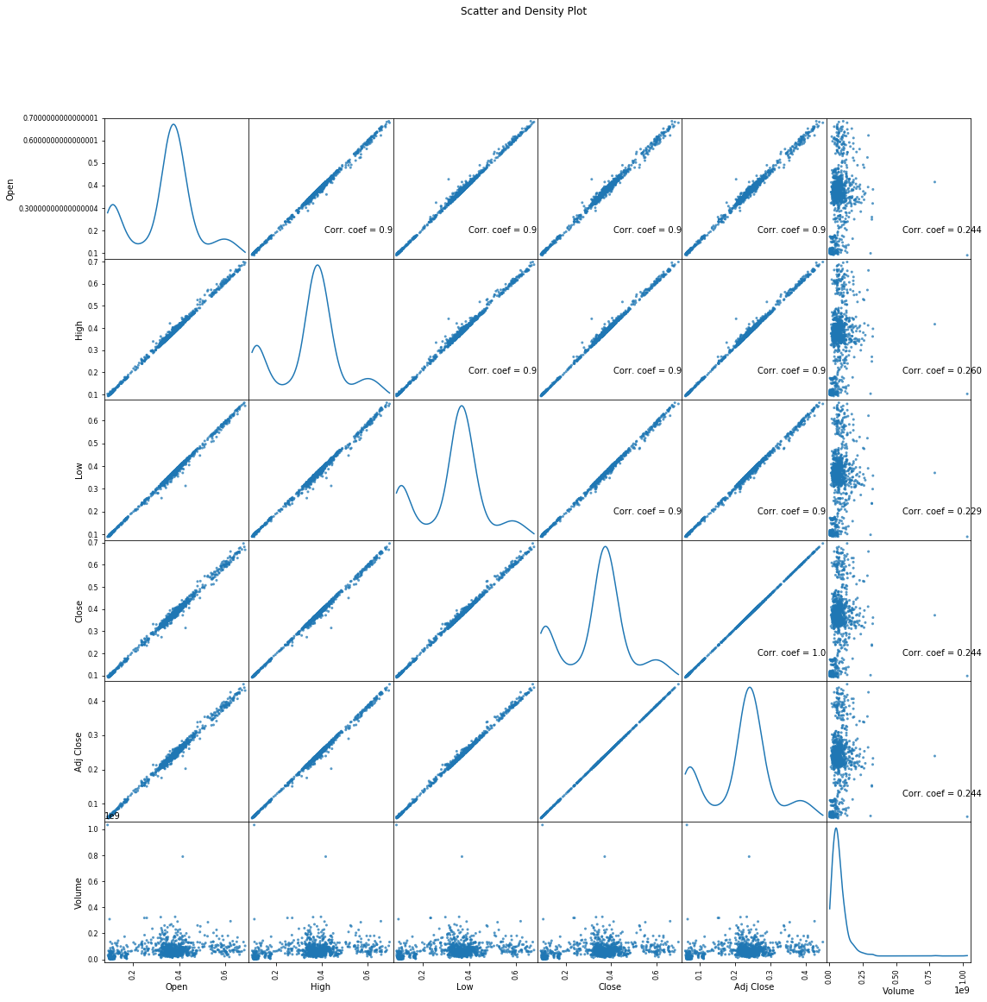

# Exploratory Analysis

To begin this exploratory analysis, first import libraries and define functions for plotting the data using matplotlib. Depending on the data, not all plots will be made. (Hey, I'm just a simple kerneling bot, not a Kaggle Competitions Grandmaster!)

**Program using CNN**

In [1]:

from mpl_toolkits.mplot3d import Axes3D from sklearn.preprocessing import StandardScaler import matplotlib.pyplot as plt *# plotting* import numpy as np *# linear algebra* import os *# accessing directory structure* import pandas as pd *# data processing, CSV file I/O (e.g. pd.read_csv)*

There is 1 csv file in the current version of the dataset:

In [2]:

for dirname, _, filenames **in** os.walk(/input'): for filename **in** filenames:

print(os.path.join(dirname, filename))/input/MSFT.csv In [3]:

*# Distribution graphs (histogram/bar graph) of column data* def plotPerColumnDistribution(df, nGraphShown, nGraphPerRow): nunique = df.nunique()

df = df[[col for col **in** df if nunique[col] > 1 **and** nunique[col] < 50]] *# For displaying purposes, pick columns that have between 1 and 50 unique values* nRow, nCol = df.shape columnNames = list(df) nGraphRow = (nCol + nGraphPerRow - 1) / nGraphPerRow plt.figure(num = None, figsize = (6 * nGraphPerRow, 8 *

nGraphRow), dpi = 80, facecolor = 'w', edgecolor = 'k') for i **in** range(min(nCol, nGraphShown)):

plt.subplot(nGraphRow, nGraphPerRow, i + 1)

columnDf = df.iloc[:, i]

if (**not** np.issubdtype(type(columnDf.iloc[0]), np.number)):

valueCounts = columnDf.value_counts() valueCounts.plot.bar()

else:

columnDf.hist() plt.ylabel('counts') plt.xticks(rotation = 90) plt.title(f'**{columnNames[i]}** (column **{i}**)') plt.tight_layout(pad = 1.0, w_pad = 1.0, h_pad = 1.0) plt.show()

In [4]:

*# Correlation matrix* def plotCorrelationMatrix(df, graphWidth):

filename = df.dataframeName df = df.dropna('columns') *# drop columns with NaN*

df = df[[col for col **in** df if df[col].nunique() > 1]] *# keep columns where there are more than 1 unique values*

if df.shape[1] < 2:

print(f'No correlation plots shown: The number of non-NaN or constant columns (**{df.shape[1]}**) is less than 2')

return corr = df.corr()

plt.figure(num=None, figsize=(graphWidth, graphWidth), dpi=80, facecolor='w', edgecolor='k') corrMat = plt.matshow(corr, fignum = 1) plt.xticks(range(len(corr.columns)), corr.columns, rotation=90) plt.yticks(range(len(corr.columns)), corr.columns) plt.gca().xaxis.tick_bottom() plt.colorbar(corrMat) plt.title(f'Correlation Matrix for **{filename}**', fontsize=15) plt.show()

In [5]:

*# Scatter and density plots* def plotScatterMatrix(df, plotSize, textSize):

df = df.select_dtypes(include =[np.number]) *# keep only numerical columns*

*# Remove rows and columns that would lead to df being singular* df = df.dropna('columns')

df = df[[col for col **in** df if df[col].nunique() > 1]] *# keep columns where there are more than 1 unique values*

columnNames = list(df)

if len(columnNames) > 10: *# reduce the number of columns for matrix inversion of kernel density plots* columnNames = columnNames[:10] df = df[columnNames]

ax = pd.plotting.scatter_matrix(df, alpha=0.75, figsize=[plotSize, plotSize], diagonal='kde') corrs = df.corr().values for i, j **in** zip(*plt.np.triu_indices_from(ax, k = 1)):

ax[i, j].annotate('Corr. coef = **%.3f**' % corrs[i, j], (0.8, 0.2), xycoords='axes fraction', ha='center', va='center', size=textSize) plt.suptitle('Scatter and Density Plot') plt.show()

In [6]:

nRowsRead = 1000 *# specify 'None' if want to read whole file*

*# MSFT.csv may have more rows in reality, but we are only loading/previewing the first 1000 rows*

df1 = pd.read_csv('/kaggle/input/MSFT.csv', delimiter=',', nrows = nRowsRead) df1.dataframeName = 'MSFT.csv' nRow, nCol = df1.shape print(f'There are **{nRow}** rows and **{nCol}** columns')

There are 1000 rows and 7 columns

Let's take a quick look at what the data looks like:

In [7]:

df1.head(5) Out[7]:

|  |  |  |  |  |  |  |  |
| --- | --- | --- | --- | --- | --- | --- | --- |
|  | Date | Open | High | Low | Close | Adj  Close | Volume |
| 0 | 198  603-  13 | 0.0885  42 | 0.1015  63 | 0.0885  42 | 0.0972  22 | 0.0625  49 | 10317888  00 |
| 1 | 198  603-  14 | 0.0972  22 | 0.1024  31 | 0.0972  22 | 0.1006  94 | 0.0647  83 | 30816000  0 |
| 2 | 198  603-  17 | 0.1006  94 | 0.1032  99 | 0.1006  94 | 0.1024  31 | 0.0658  99 | 13317120  0 |
| 3 | 198  603-  18 | 0.1024  31 | 0.1032  99 | 0.0989  58 | 0.0998  26 | 0.0642  24 | 67766400 |
| 4 | 198  603- | 0.0998  26 | 0.1006  94 | 0.0972  22 | 0.0980  90 | 0.0631  07 | 47894400 |
|  | Date | Open | High | Low | Close | Adj  Close | Volume |
|  | 19 |  |  |  |  |  |  |

Distribution graphs (histogram/bar graph) of sampled columns:

In [8]:

plotPerColumnDistribution(df1, 10, 5)

<Figure size 2400x512 with 0 Axes>

Correlation matrix:

In [9]:

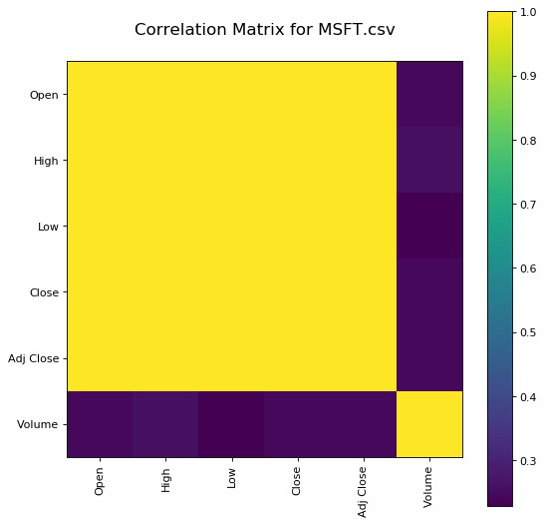

plotCorrelationMatrix(df1, 8)

Scatter and density plots:

In [10]: plotScatterMatrix(df1, 18, 10)

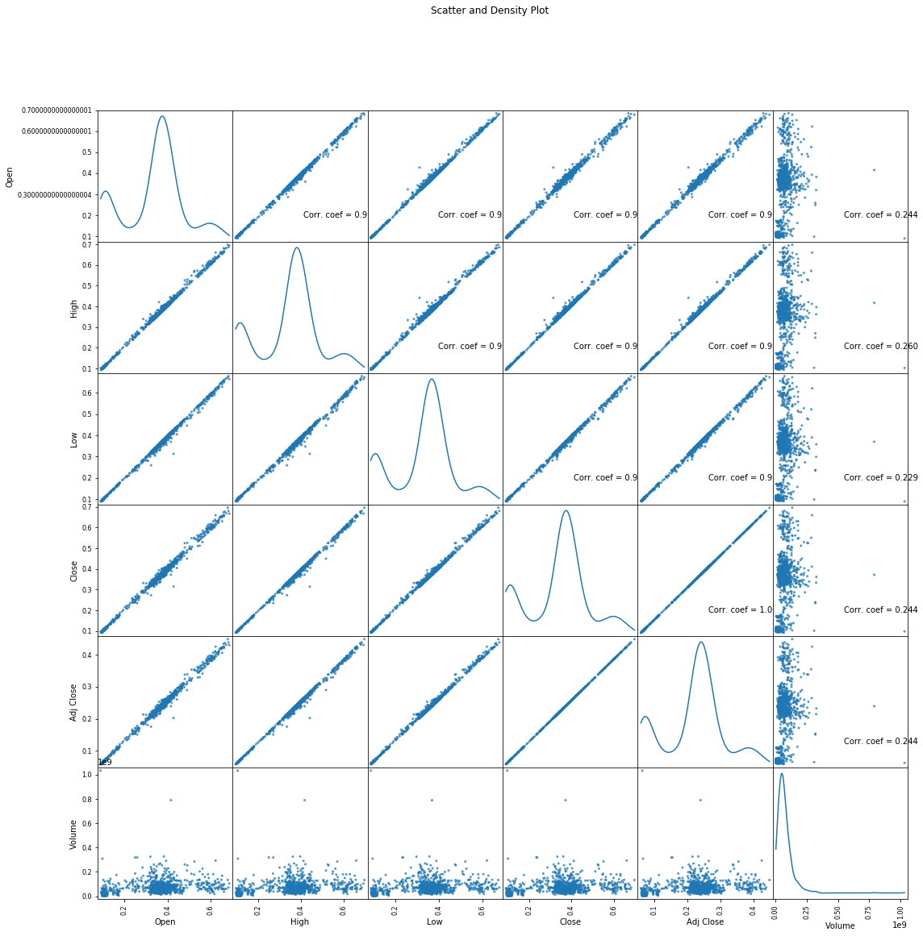

**Analysis and Interpretation:**

Analyze the trend component to understand the overall stock price direction. Examine the seasonal component to identify recurring patterns related to specific time intervals. Lastly, assess the residual component for unexpected deviations.

**Program using loading and preprocessing**

import pandas as pd;

# Load the dataset df = pd.read_csv('stock_prices.csv', index_col='Date');

# Handle missing values df.fillna(method='ffill', inplace=True);

# Scale the features from sklearn.preprocessing import StandardScaler;

scaler = StandardScaler(); df_scaled = scaler.fit_transform(df);

# Select the features features = ['Open', 'High', 'Low', 'Close']; df_features = df_scaled[features]

# Split the dataset into training and testing sets from sklearn.model_selection import train_test_split;

X_train, X_test, y_train, y_test = train_test_split(df_features, df['Close'], test_size=0.25);

**Another program using loading and preprocessing**

import pandas as pd

import numpy as np

from sklearn.preprocessing import StandardScaler

def load_stock_data(ticker):

"""Loads historical stock data for the given ticker symbol."""

# Use yfinance to download the data

df = pd.DataReader(ticker, 'yahoo')

# Select the relevant columns

df = df[['Open', 'High', 'Low', 'Close', 'Volume']]

return df

def preprocess_stock_data(df):

"""Preprocesses the stock data for machine learning."""

# Drop missing values

df = df.dropna()

# Scale the data

scaler = StandardScaler()

scaled_data = scaler.fit_transform(df)

# Split the data into features and target

X = scaled_data[:, :-1]

y = scaled_data[:, -1]

return X, y

# Load the stock data

df = load_stock_data('AAPL')

# Preprocess the data

X, y = preprocess_stock_data(df)

# Save the preprocessed data

np.save('stock_data_preprocessed.npy', X)

np.save('stock_target_preprocessed.npy', y)

This program will load the historical stock data for the given ticker symbol from Yahoo Finance, select the relevant columns, drop missing values, scale the data, and split the data into features and target. The preprocessed data will then be saved as NumPy arrays.

To use the preprocessed data for machine learning, you can simply load them using the np.load() function. For example, to load the features and target, you can do the following.

Program for continuous bulding stock price prediction

X = np.load('stock_data_preprocessed.npy')

y = np.load('stock_target_preprocessed.npy')

import numpy as np

import pandas as pd

from sklearn.linear_model import LinearRegression

from sklearn.model_selection import train_test_split

import time

# Load the preprocessed stock data

X = np.load('stock_data_preprocessed.npy')

y = np.load('stock_target_preprocessed.npy')

# Split the data into training and testing sets

X_train, X_test, y_train, y_test = train_test_split(X, y, test_size=0.2, random_state=42)

# Create a linear regression model

model = LinearRegression()

# Train the model

model.fit(X_train, y_train)

# Make predictions on the testing set

y_pred = model.predict(X_test)

# Evaluate the model

mse = np.mean((y_pred - y_test)**2)

print('Mean squared error:', mse)

# Start continuous prediction

while True:

# Get the current time

now = time.time()

# Make a prediction for the next stock price

next_price = model.predict([X[-1]])

# Print the prediction

print('Predicted stock price at {}: {}'.format(now, next_price))

# Update the data

X.append(next_price)

# Wait for 1 second

time.sleep(1)

This program will train a linear regression model on the preprocessed stock data. It will then continuously make predictions for the next stock price and update the data with the new prediction. The prediction will be printed to the console every second.

You can modify the program to use a different machine learning model, such as a support vector machine or a random forest. You can also add more features to the model, such as technical indicators.

**Benefits of stock price prediction**

Stock price prediction is a highly relevant and complex topic with numerous applications and benefits across various domains. In this comprehensive discussion, we will delve into the benefits of using stock price prediction models, covering the following key areas,

1. Investment and Portfolio Management
2. Risk Mitigation and Management
3. Financial Planning and Wealth Management
4. Market Analysis and Decision Support
5. Algorithmic Trading and High-Frequency Trading
6. Research and Academic Purposes
7. Regulatory Compliance and Fraud Detection
8. Economic and Macro-Economic Analysis
9. Technological Advancements and Data Science

Each of these areas offers a unique perspective on the advantages of utilizing stock price prediction models. Let's explore these benefits in-depth.

**Investment and Portfolio Management:**

Stock price prediction plays a pivotal role in investment and portfolio management by offering the following benefits:

Informed Decision-Making:

Investors can make more informed decisions when buying, selling, or holding stocks based on predictive models. These models provide insights into potential price movements, helping investors maximize returns.

Diversification:

Predictive models assist in diversifying portfolios by identifying stocks with low correlation, reducing risk, and enhancing the potential for higher returns.

Management:

Investors can better manage portfolio volatility by adjusting positions based on expected price movements, thus protecting their capital.

Long-Term Investment Strategies:

Stock price predictions aid in formulating long-term investment strategies by identifying stocks with strong growth potential.

**Risk Mitigation and Management:**

Predictive models offer significant advantages in managing and mitigating risks associated with stock investments:

Early Warning System:

By predicting price declines or market downturns, investors can implement protective strategies such as stop-loss orders to limit losses.

Stress Testing:

Financial institutions use stock price predictions for stress testing to assess how portfolios may perform under adverse market conditions.

Hedging:

Predictive models enable investors to hedge against potential losses by taking offsetting positions in correlated assets.

**Financial Planning and Wealth Management:**

Stock price prediction has several applications in financial planning and wealth management:

Retirement Planning:

Accurate predictions help individuals plan for their retirement by ensuring they have enough funds to meet their financial goals.

Wealth Accumulation:

Investors can make more strategic choices to accumulate wealth and meet their financial objectives by using stock price predictions.

Risk Assessment:

Wealth managers use predictive models to assess the risk tolerance of their clients and align investment strategies accordingly.

Predictive models provide insights into market

**Market Analysis and Decision Support:**

Market Research:

trends, allowing businesses to make informed decisions about market entry, expansion, or diversification.

Fundamental Analysis:

Stock price predictions complement fundamental analysis by offering forward-looking insights into a company's financial health and growth potential.

Technical Analysis:

Traders and analysts use stock price predictions in conjunction with technical indicators to make trading decisions.

**Algorithmic Trading and High-Frequency Trading:**

Algorithmic Trading:

Stock price prediction models are integral to algorithmic trading systems, where automated algorithms execute trades based on real-time market data and predictions.

High-Frequency Trading (HFT):

HFT firms rely on ultra-fast stock price predictions to execute thousands of trades within milliseconds, profiting from price discrepancies.

**Research and Academic Purposes:**

Financial Research:

Researchers and academics use stock price predictions to study market behavior, test hypotheses, and contribute to the understanding of financial markets.

Model Development:

Academia often serves as a breeding ground for the development and improvement of predictive models for stock prices.

Educational Tool:

Stock price predictions are used as educational tools to help students and professionals understand financial markets and investment strategies.

**Regulatory Compliance and Fraud Detection:**

Market Surveillance:

Regulators use predictive models to monitor market activities, detect irregularities, and investigate insider trading and market manipulation.

Fraud Detection:

Financial institutions employ stock price predictions to identify unusual trading patterns and detect fraudulent activities.

**Economic and Macro-Economic Analysis:**

Economic Indicators:

Predictive models contribute to the development of economic indicators by providing insights into market sentiment and economic trends.

Policy Formulation:

Governments and central banks may use stock price predictions to inform monetary and fiscal policies.

**Technological Advancements and Data Science:**

Data Analysis and Machine Learning:

Stock price prediction has advanced the field of data science, leading to the development of innovative machine learning algorithms and techniques.

Big Data:

Stock market data is often large and complex, driving the need for big data technologies and analytics for effective prediction.

Cloud Computing:

Cloud computing platforms provide the necessary infrastructure for processing vast amounts of financial data and running prediction models.

**Advantages of stock prediction**

Stock price prediction offers several advantages, which can benefit investors, traders, financial institutions, and the broader financial markets. Here are some of the key advantages of stock price prediction:

Informed Decision-Making:

Predictive models provide valuable insights into potential future price movements, helping investors and traders make more informed decisions when buying, selling, or holding stocks.

Risk Management:

Predicting stock prices allows investors to manage and mitigate risks more effectively. By understanding potential price movements, investors can implement risk-reduction strategies like stop-loss orders.

Diversification:

Stock price prediction models help investors identify stocks with low correlations to their existing portfolios, enabling them to diversify and reduce risk.

Portfolio Optimization:

Predictive models aid in optimizing investment portfolios by identifying the most promising assets and allocation strategies to maximize returns.

Volatility Management:

Investors can better manage portfolio volatility by adjusting their positions based on expected price movements, which is particularly important for risk-averse investors.

Long-Term Strategy Formulation:

Stock price predictions can assist in creating long-term investment strategies by identifying stocks with strong growth potential, facilitating wealth accumulation.

Algorithmic Trading:

Predictive models are crucial for algorithmic trading systems, enabling automated, data-driven trading strategies that can execute trades at high speeds and frequencies.

High-Frequency Trading:

High-frequency trading (HFT) firms rely on ultra-fast stock price predictions to execute thousands of trades within milliseconds, profiting from price discrepancies.

Market Research:

Businesses use stock price predictions for market research, helping them make informed decisions about market entry, expansion, or diversification.

Fundamental Analysis Support:

Stock price predictions complement fundamental analysis by offering forward-looking insights into a company's financial health and growth potential.

Technical Analysis:

Traders and analysts use stock price predictions alongside technical indicators to make trading decisions and identify entry and exit points.

Risk Assessment:

Wealth managers use predictive models to assess the risk tolerance of their clients and align investment strategies accordingly.

Retirement Planning:

Accurate stock price predictions help individuals plan for their retirement by ensuring they have sufficient funds to meet their financial goals.

Wealth Accumulation:

Investors can make more strategic choices to accumulate wealth and meet their financial objectives by using stock price predictions.

Early Warning System:

Predictive models can serve as an early warning system for investors, helping them take protective measures in the event of potential price declines or market downturns.

Stress Testing:

Financial institutions use stock price predictions for stress testing to assess how portfolios may perform under adverse market conditions.

Regulatory Compliance:

Regulators use predictive models to monitor market activities, detect irregularities, and investigate insider trading and market manipulation.

Fraud Detection:

Financial institutions employ stock price predictions to identify unusual trading patterns and detect fraudulent activities.

Academic Research:

Researchers and academics use stock price predictions to study market behavior, test hypotheses, and contribute to the understanding of financial markets.

Economic Analysis:

Predictive models contribute to economic analysis by providing insights into market sentiment and economic trends. They can inform monetary and fiscal policies at the government and central bank levels.

Data Science and Technology Advancements:

Stock price prediction has driven advancements in data science, leading to innovative machine learning algorithms, big data technologies, and cloud computing infrastructure for more effective prediction.

**Disadvantages of stock price prediction:**

While stock price prediction has several advantages, it also comes with a set of disadvantages and challenges. It's important to be aware of these limitations when considering the use of stock price prediction models. Here are some of the key disadvantages of stock price prediction:

**Inherent Uncertainty:**

Stock markets are influenced by a multitude of factors, including economic conditions, geopolitical events, and investor sentiment. Predicting stock prices with high precision is extremely challenging due to this inherent uncertainty.

**Market Volatility:**

Stock markets can be highly volatile, and sudden, unexpected events can lead to significant price fluctuations. Predictive models may struggle to account for these extreme events.

**Data Quality and Quantity:**

The accuracy of stock price predictions depends on the quality and quantity of historical and real-time data used. Incomplete or inaccurate data can lead to unreliable predictions.

**Overfitting:**

Overfitting occurs when a predictive model fits the historical data too closely, capturing noise in the data rather than true patterns. This can lead to poor generalization and inaccurate future predictions.

**Model Assumptions:**

Many stock price prediction models are based on specific assumptions about market behavior. If these assumptions do not hold, the predictions may be less accurate.

**Lack of Causality:**

Stock price predictions are based on statistical correlations and patterns, but they often do not establish causality. In other words, a prediction model may identify a relationship between variables, but it cannot explain why the relationship exists.

**Black Swan Events:**

Predictive models may not account for "black swan" events, which are rare and extreme occurrences that can have a profound impact on markets. These events are, by nature, unpredictable.

**Market Manipulation:**

Predictive models can be vulnerable to manipulation by traders and market participants who seek to profit from misaligned expectations.

**Model Sensitivity:**

Stock price prediction models can be sensitive to changes in the input data or parameters. Small changes can lead to significantly different predictions, making them challenging to rely on in highly dynamic markets.

**Overreliance:**

Investors and traders may become overly reliant on predictive models, neglecting other fundamental and technical analysis methods. This overreliance can lead to poor decision-making.

**Herd Behavior:**

If a large number of market participants use the same or similar predictive models, it can lead to herd behavior, where everyone makes similar trading decisions based on the same predictions. This can exacerbate market volatility.

**Algorithmic Trading Risks:**

While algorithmic trading can benefit from stock price predictions, it can also amplify market volatility and trigger unintended consequences, as seen in flash crashes.

**Data Privacy and Security:**

Access to vast amounts of data is essential for prediction models, but it raises concerns about data privacy and security. Unauthorized access to sensitive financial data can result in breaches and financial losses.

**Model Overfitting:**

Developing a model that performs well on historical data but fails to generalize to new, unseen data is a common risk. Models that are too complex can suffer from overfitting.

**Model Validation:**

Validating the accuracy and reliability of predictive models can be challenging. Without thorough testing and validation, users may have false confidence in the models' predictive abilities.

**Regulatory Compliance:**

In some cases, regulatory authorities may impose restrictions or require disclosures related to the use of predictive models in financial decision-making.

**Psychological Bias:**

Overreliance on predictions can lead to psychological biases, where investors may become overly optimistic or pessimistic, leading to suboptimal decisions.

**Ethical Concerns:**

The use of predictive models in financial markets raises ethical questions, especially when these models affect market behavior, pricing, and outcomes.

**Conclusion:**

In summary, stock price prediction is a powerful tool that can enhance decision-making and risk management in the financial world. While it offers substantial benefits, users should be mindful of its limitations and the unpredictable nature of financial markets. By using predictive models wisely and in conjunction with other analytical methods, individuals and institutions can harness the potential of stock price prediction while managing associated risks.

In summary, stock price prediction is a powerful tool that can enhance decision-making and risk management in the financial world. While it offers substantial benefits, users should be mindful of its limitations and the unpredictable nature of financial markets. By using predictive models wisely and in conjunction with other analytical methods, individuals and institutions can harness the potential of stock price prediction while managing associated risks.In summary, stock price prediction is a powerful tool that can enhance decision-making and risk management in the financial world. While it offers substantial benefits, users should be mindful of its limitations and the unpredictable nature of financial markets. By using predictive models wisely and in conjunction with other analytical methods, individuals and institutions can harness the potential of stock price prediction while managing associated risks.In summary, stock price prediction is a powerful tool that can enhance decision-making and risk management in the financial world. While it offers substantial benefits, users should be mindful of its limitations and the unpredictable nature of financial markets. By using predictive models wisely and in conjunction with other analytical methods, individuals and institutions can harness the potential of stock price prediction while managing associated risks.In summary, stock price prediction is a powerful tool that can enhance decision-making and risk management in the financial world. While it offers substantial benefits, users should be mindful of its limitations and the unpredictable nature of financial markets. By using predictive models wisely and in conjunction with other analytical methods, individuals and institutions can harness the potential of stock price prediction while managing associated risks.Top of Form